**QSMART – Q-SMART BACK MIRROR ASSY REPLACEMENT**

**PROCEDURE**

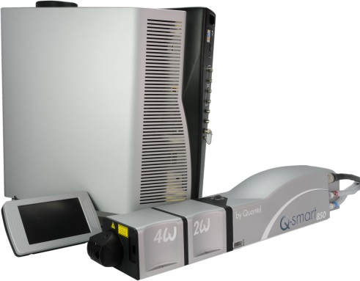

**Toolkit:**

Screwdrivers

Allen keys

RP100016 special toolkit for Q-smart

**System**: QSMART

|  |  |  |  |
| --- | --- | --- | --- |
| |  |  | | --- | --- | | **SM010345** | **Q-SMART BACK MIRROR ASSY** | |  |

**Purpose**: This document details how to change and adjust the back mirror

|  |  |  |
| --- | --- | --- |
| Revision | date | modification |
| Initial issue | July 4, 2014 |  |
|  |  |  |
|  |  |  |
|  |  |  |

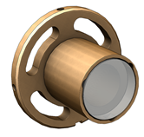

# DISASSEMBLING

* Turn the system off
* Disconnect cables and water hoses from the side of the laser head side
* Remove the laser head cover.
* Remove the side plate (7 BHC 3x6)

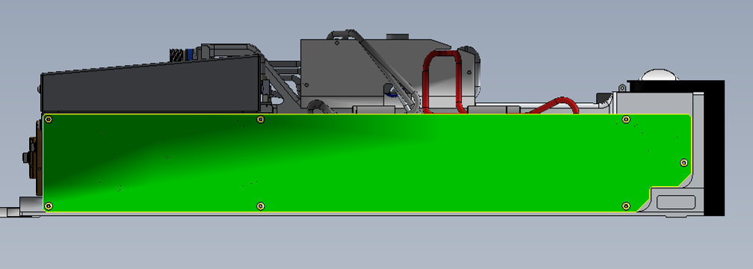

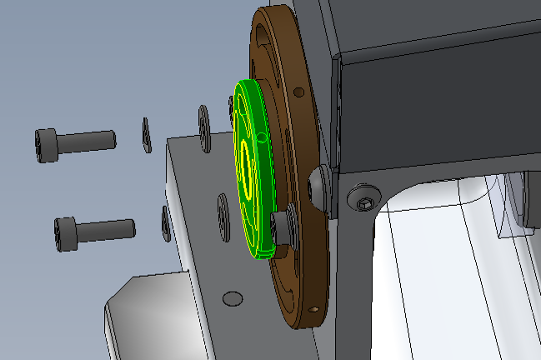

* Take the back mirror barrel away (2 CHC screws 3x8 + 2 Onduflex d3 3/E13/0082 washers + 2 MU3 washers).
* Put the new barrel before adjusting the laser.

# LASER ADJUSTMENT (Beam analyzer or burn paper)

*Refer to Laser Adjustment procedure.*

* Close the Laser head and put warranty stickers   
  *Refer to "LH-Warranty Labels"*